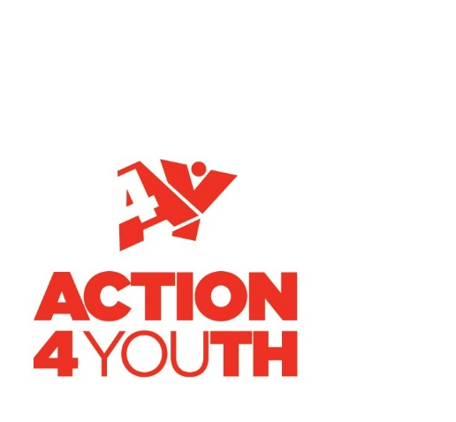
Job Description

Job Title

- NCS Assistant Team Leader

Location

- Aylesbury Vale area and at residentials both in Gloucestershire and in Milton Keynes/Aston Clinton.

Position in the Organisation

- Reports To: NCS Project Leader
- Responsible For: Assisting the Team Leader in supervising young people aged 16 - 17 years old in groups of 12 - 16
- Working With: NCS Team

Main Purpose and Scope of the Role

NCS Assistant Team Leaders will be split between two cohorts. They will help the NCS Team Leader support their cohort of 12 to 16 young people on the Action4Youth National Citizen Service programme over a period of three consecutive weeks. The Assistant may also need to provide one to one support for young people with special educational needs.

The cohorts will include a mixture of young people from different backgrounds, some of whom may have disabilities or behavioural difficulties. You will supervise the same groups throughout and will be required to stay overnight during the residential elements of the programme. You are also required to attend the staff training event and teambuilding day. During the programme you are responsible to the NCS Wave Leader and NCS Project Manager.

Programme Structure and Your Role:

Week 1 - Residential (4 nights, 5 days) at an outdoor activity centre aimed at team building:

- Follow structured activity timetable
- Supervise young people and manage behaviour during all activities.
- Enthuse and get involved in all activities.
- Be proactive and lead by example at all times
- Ensure your group is on time and following behavioural code of conduct
- Assist at mealtimes and bedtimes; including one night duty
- Help facilitate quality Guided Reflection sessions on a daily basis
- Provide 1:1 support to young people with additional needs

Week 2 - Residential (4 nights, 5 days) at Caldecotte Xperience (wave 2 Greeen Park), focuses on being a Responsible Citizen:

As above for week 1, plus;

- Follow structured timetable and assist your group during activities and travel.
- Help cook meals when your group is doing ‘Come Dine with NCS’
- Supervise your group off site during their charity visit
- Assist your group with their Social Action Project planning and their Dragons Den presentation - allow young people to take the lead but be involved at all times and direct ideas and planning so it is feasible and achievable. Your input will be key to keeping them on target.
- Ensure all of your group is clear on the plans for week three (Social Action Project)
- Ensure risk assessments are in place for social action project activities the following week

Week 3 – Non-residential – implementing social action project

- Meet with your group every day at the location provided.
- Support your group with the delivery of their project.
- To communicate clearly with charity partners regarding projects and ensure that they are kept up to date at all times
- Provide adult supervision and be present at events and activities.
- Ensure Health and Safety procedures have been followed and incidents reported.
- Ensure quality Guided Reflection sessions happen on a daily basis

Duties and Key Responsibilities

To supervise young people in all activities, both at residential and non-residential locations. To include:
- Away and home travel
- Taking registers of participants on both outbound and inward journeys.
- Ensure participants are fully versed with travel arrangements both outbound and inbound journeys.
- To actively take part in daily activities both indoor and outdoor and assist your Team Leader in supervising your group.
- To provide support and direction to all group members.
- To guide and assist your group through a Personal and Social Development programme.
- To monitor students’ welfare throughout course and to be especially aware of recorded allergies, physical and mental conditions, and to follow the procedures in place.
- To liaise and communicate with NCS Wave Leader, Action4Youth staff and your Team Leader on a regular basis.

General Responsibilities

- Support the continued development of quality standards as specified by Action4Youth.
- To have regard for the vision of Action4Youth and to display a commitment to equal opportunities and to the protection and safeguarding of children, young people and vulnerable adults.
- Report any behaviour, conversations or comments which are inappropriate within a setting for children and young people.
- To carry out any other Action4Youth duties as required by your Line Manager, CEO or Directors.
- Administering own workload which includes meeting targets and deadlines in line with the Action4Youth Performance Management System.
- Attending relevant CPD training events in line with Performance Management appraisal.
- Undertaking responsibility, as part of the team, for all Health and Safety work related matters.
- Working within the guidelines of Action4Youth policies and procedures.

Terms and Conditions

Place of work: | Aylesbury Vale area and at residentials both in Gloucestershire and in Milton Keynes/Aston Clinton
Transport | Transport to and from residential sites will be provided via coach from pick up location in Aylesbury. You will be expected to make your own travel arrangements for week three.
DBS Pre-Employment Check | Appointment to this post is subject to an Enhanced DBS check.
Meals and Accommodation: | Whilst on residentials you are entitled to free meals plus on-site accommodation.
References: | Employment will be subject to receiving two satisfactory references
Proof of Eligibility to work in the UK | Evidence provided to comply with the  Immigration, Asylum and Nationality Act 2006
Training: | It is compulsory that you attend the NCS Staff Training day on Saturday 15th June and Teambuilding day on Sunday 16th June. You must complete the NCS Trust E- learning module by Friday 3rd May.

